Supporting Information
Note S1:
Alkaline phosphatase (ALP), widely distributed in bone, intestine, kidney and other tissues, is one of the diagnostic indexes for bone disease. The total alkaline phosphatase (TALP) level of patients with osteopenia or osteoporosis is higher than that of normal subjects.
Osteocalcin (OSTEOC), the most abundant proteins in bone and produced exclusively by osteoblasts, was initially believed to be an inhibitor of bone mineralization and now have proved to be a useful indicator of bone formation. The faster the bone regeneration rate, the higher the osteocalcin value, and vice versa.
Procollagen type 1 carboxypeptide (PICP) and procollagen type 1 N-propeptide (P1NP) have been proven to be markers of bone formation. They reflect osteoblasts activity and bone formation rate.
Vitamin D (VIT-D) plays a key role in nutritional risk mediated osteoporosis. Vitamin D deficiency, associated with increased bone turnover, can be an important risk factor for osteoporosis.

Table S1
WEIGHTS SETTING for Age Groups
Age groups | The percentage of positive class | The percentage of sample | Weight
＜35 | 0 | 3.47 % | 0
35-50 | 10.00 % | 9.90 % | 0.5
50-65 | 18.18 % | 43.56 % | 0.75
65-80 | 26.03 % | 36.14 % | 1
≥80 | 21.43 % | 6.93 % | 0.75

Table S2
DIFFERENT COMBINATIONS of BMTs
 | Sex | Age | BMI | TP1NP | PICP | OSTEOC | VIT-D | ALP | Ca | Phos.
1 | √ | √ | √ | √ | √ | √ | √ | √ | √ | √
2 | √ | √ | √ | √ |  | √ |  |  | √ | √
3 | √ | √ | √ | √ |  |  |  |  | √ | √
4 | √ | √ | √ |  | √ |  |  |  | √ | √
5 | √ | √ | √ |  |  |  |  | √ | √ | √
6 | √ | √ | √ | √

Table S3
CLASSIFICATION PERFORMANCEs
Test  number | Classification  Accuracy | Precision | Recall | ROC-AUC  values
1 | 0.8861 | 0.6545 | 0.9 | 0.8914
2 | 0.8812 | 0.6379 | 0.925 | 0.8977
3 | 0.8515 | 0.5833 | 0.875 | 0.8603
4 | 0.8020 | 0.5 | 0.875 | 0.8295
5 | 0.7821 | 0.4722 | 0.85 | 0.8077
6 | 0.7723 | 0.4583 | 0.8250 | 0.7921

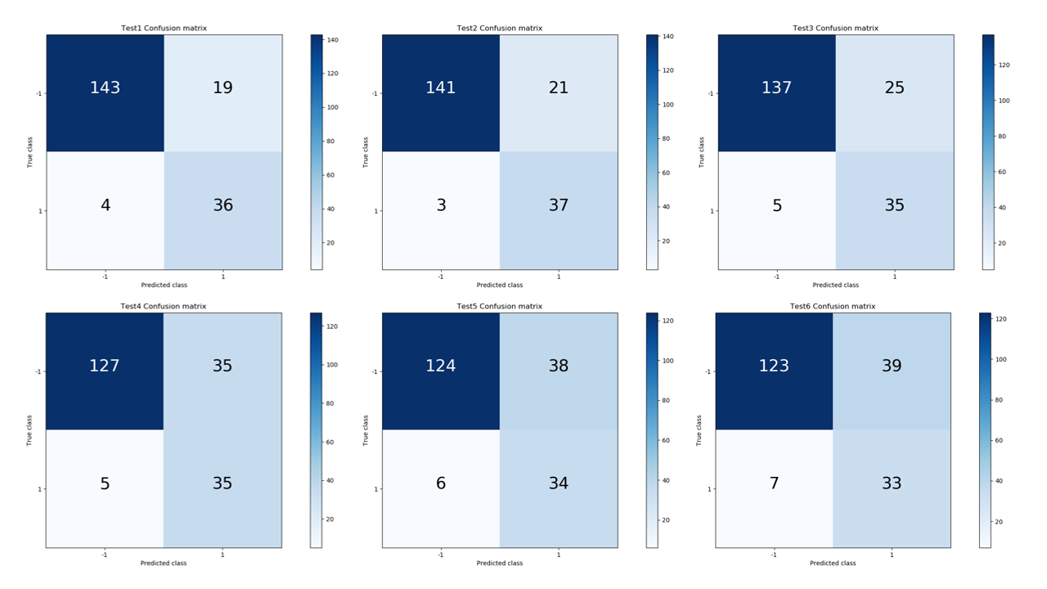
Fig. S1 Confusion matrices of the tests

